1

Criterion C: Development

1. Integrator Algorithms 2
1-1. Verlet Algorithm 3
1-2. Boris Pusher Algorithm 4
2. Data-Oriented Design(DOD) 5
2-1. Vector Object 5
2-2. List 7
3. Animation Controller 9
4. Input Validation 12
5. Sources 16
5-1. Verlet Integrator 16
5-2. Boris Pusher 16
5-3. Flutter’s Animation Controller&Widgets 16
5-4. Accumulator Time Step Management 16

1. Integrator Algorithms
Physics simulation requires algorithms to estimate continuous motion because computers can only compute discrete data. To satisfy SC 1, using an appropriate algorithm is crucial.
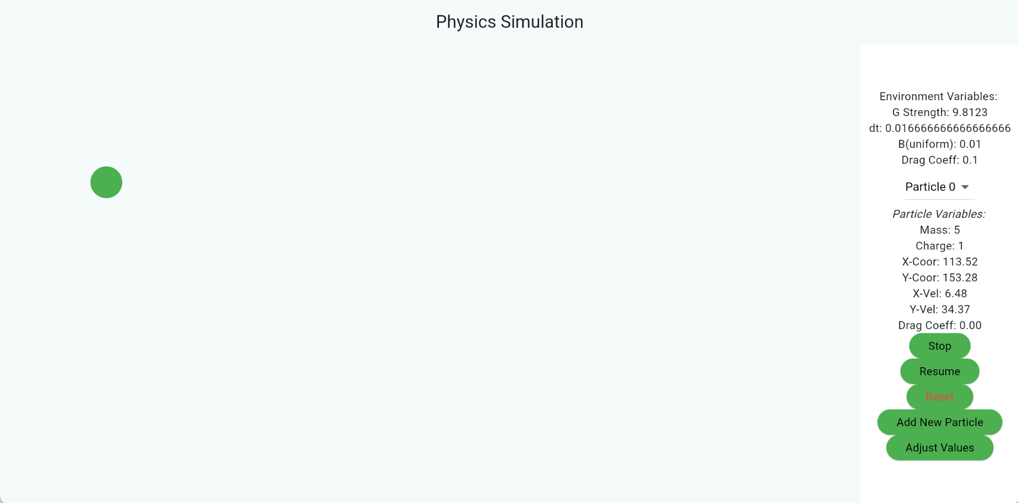
Figure 1: Screenshot 1
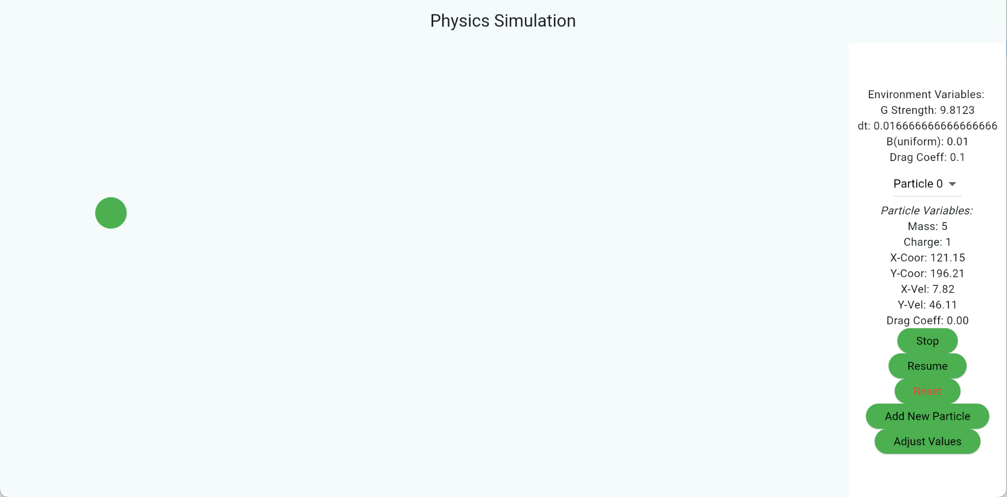
Figure 2: Screenshot 2, a few seconds later from Screenshot 2
Numeric integrators update positions and velocities that are also displayed on the right side of the screen, as shown in Figures 1 and 2.

1-1. Verlet Algorithm
void updatePosition(Particle p, int n) {
//Step 1 in Criterion C, 5-2-2 Flowchart
Vec2 acc = calculateAcc(p);
p.velPlusHalf = p.vel + acc * (dt / 2);

//Step 2 in Criterion C, 5-2-2 Flowchart
p.velPlusHalf = borisPush(p, p.E, B, p.velPlusHalf);

//Step 3 in Criterion C, 5-2-2 Flowchart
p.pos = p.pos + p.velPlusHalf * dt.toDouble();

//Step 4 in Criterion C, 5-2-2 Flowchart
Vec2 accPredict = calculateAcc(p);
p.vel = p.velPlusHalf + accPredict * (dt / (2));
}
Figure 3. updatePosition() function

I primarily used the Verlet integrator to calculate each particle’s motion(Criterion C, section 5-2-2). The velocity Verlet concerns forces other than those due to EM fields. This is done with the calculateAcc() function(Figure 3). I used the Boris Pusher algorithm to adjust motion under the Lorentz force, accounting for other forces (Figure 3).
The Euler method could also be appropriate because the simulation is simple and does not run a long time. However, choosing a more accurate algorithm will help expand the project in the future.
Another reason for choosing the Verlet algorithm is that Boris Pusher works particularly well when paired with it. The Verlet algorithm includes the calculation of velocity at the previous half-time step, which Boris Pusher also requires as a parameter (see the flowchart in Criterion C, section 5-3). The implemented updatePosition() first calculates the velocity half a time step ahead and passes it as a parameter to the borisPusher() function(Figure 3). With the Verlet algorithm, half-time-step velocities do not need to be interpolated, thereby improving the accuracy of computed acceleration, velocity, and position.

1-2. Boris Pusher Algorithm
Vec2 borisPush(Particle p, Vec2 E, double dt, Vec2 vel) {

//Step 1 in Criterion C, 5-3 Flowchart
double t = p.q / p.m * B * 0.5 * dt;

//Step 2 in Criterion C, 5-3 Flowchart
double s = 2 * t / (1 + t*t);

//Step 3 in Criterion C, 5-3 Flowchart
Vec2 vMinus = p.velPlusHalf + (E * ((p.q / p.m) * 0.5 * dt));

//Step 4 in Criterion C, 5-3 Flowchart
Vec2 vPrime = vMinus + zCrossProduct(vMinus, t);

//Step 5 in Criterion C, 5-3 Flowchart
Vec2 vPlus = vMinus + zCrossProduct(vPrime, s);

//Step 6 + exit in Criterion C, 5-3 Flowchart
return vPlus + (E * ((p.q / p.m) * 0.5 * dt));
}
Figure 4. borisPush() function

I incorporated Boris Pusher(Figure 4) into the Velocity Verlet Integrator(see the flowchart in Criterion C, section 5-2-2, and Figure 3).
The energy should be preserved in the simulation to ensure accuracy, and since it assumes the absence of non-conservative forces. The energy spiral is exacerbated when the Lorentz force is present, leading to significant errors. Therefore, other algorithms, such as Euler, Runge-Kutta, and Verlet, are inappropriate, whereas the Boris Pusher offers unparalleled accuracy. (Appendix 2-2).

2. Data-Oriented Design(DOD)
While object is the predominant feature of OOP, encapsulating methods is not appropriate for physics simulation. Encapsulation is usually used when each object has its own distinct functionality. However, all objects in the simulation are governed by the same algorithm described in Criterion B, section 5-1; there is no need to create methods; doing so would be inefficient.

2-1. Vector Object
A vector is a quantity that has both direction and magnitude. In programming, a vector has two values. The difference between the two values indicates the magnitude and direction.

In my program, I created a vector object called “Vec2” that contains x and y values.

class Vec2 {
double x, y;

Vec2(this.x, this.y);

Vec2 operator +(Vec2 o) => Vec2(x + o.x, y + o.y);
Vec2 operator -(Vec2 o) => Vec2(x - o.x, y - o.y);
Vec2 operator *(double s) => Vec2(x * s, y * s);
Vec2 operator /(double s) => Vec2(x / s, y / s);
Vec2 operator ^(double s) => Vec2(pow(x, s).toDouble(), pow(x, y).toDouble());
}
Figure 5. Vec2 class

In the Vec2 class, I added additional operations to make the codebase more coherent and concise(Figure 5). This operation overloading allowed me to add and subtract vectors, multiply and divide vectors by a scalar, and exponentiate vectors to a scalar.

Vec2 pos = Vec2(0, 0);
Vec2 vel = Vec2(0, 0);
Vec2 acc = Vec2(0, 0);

Figure 6. Representing vector quantities with Vec2 objects.

Since Vec2 includes x and y, I can use it for physical vector quantities such as position and velocity(Figure 6).
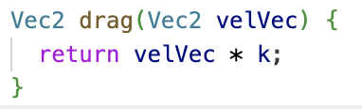
Figure 7. Example use of the Vec2 class.

Because Vec2 is an object like a String in Java, it is very versatile, and I can use it as a parameter and return type, as well as for calculations in the simulation (Figure 7).

If I had used an array instead of an object, I would have had to use extensive loops for arithmetic operations. Using an object also improved the program's conciseness.

2-2. List
Like vectors, each particle is represented as an object of the Particle class(Figure 8).
class Particle {
double blockWidth = 50;

double q = 0.0; //for simplicity of calculation; it will only hold integer values
double m = 0; //unit: kg
double r = 0;
Color col = Color.fromRGBO(76, 175, 80, 1);

double A = 1.333333333333333 * pi; //3/4 * pi

double dragCoeff = 0; //average drag coefficient of the object.

Vec2 acc = Vec2(0, 0);

Vec2 pos = Vec2(0, 0);

Vec2 velPlusHalf = Vec2(0, 0);

bool accelerate = true;

Vec2 vel = Vec2(0, 0);

double qd = 0;

Vec2 E = Vec2(10, 10); //Unit: Newton / Columb.

Particle(
this.acc,
this.pos,
this.velPlusHalf,
this.vel,
this.m,
this.q,
this.r,
this.col,
) {
vel = velPlusHalf;
A = pi * r * r;
qd = dt * q / (2 * m);
}

Widget toWidget() => Positioned(
left: pos.x,
top: pos.y,

child: Container(
width: r * 2,
height: r * 2,
decoration: BoxDecoration(color: col, shape: BoxShape.circle),
),
);
}
Figure 8. Particle class.
static List<Particle> particles = [];
Figure 9. Declaring Particle List

I used a list to store all particles(Figure 9), where an individual particle is an object(Figure 8). This is a deliberate choice because the user may want to add more particles in the simulation. Creating a fixed-size array may consume unnecessary memory or be insufficient if the user wants to add more particles than the array can hold.

void update(List<Particle> particles) {
double screenWidth = MediaQuery.of(context).size.width;
double screenHeight = MediaQuery.of(context).size.height;
for (int i = 0; i < particles.length; i++) {
//iterate the "particles" list for all particles

if (particles[i].pos.x <= 0) {
//particle going beyond left boundary
particles[i].pos.x = 1; //return the particle to the leftmost position
particles[i].accelerate = false; //prevent further acceleration
} else if (particles[i].pos.x >=
screenWidth - 4 * particles[i].r - displayWidth) {
//particle going beyond right boundary
particles[i].pos.x =
screenWidth -
4 * particles[i].r -
1; //return the particle to the rightmost position
particles[i].accelerate = false; //prevent further acceleration
}

if (particles[i].pos.y <= 0) {
//particle going beyond maximum height
particles[i].pos.y = 1; //return the particle to the maximum position
particles[i].accelerate = false; //prevent further acceleration
} else if (particles[i].pos.y >= screenHeight - 4 * particles[i].r) {
//particle going below minimum height
particles[i].pos.y =
screenHeight -
4 * particles[i].r -
1; //return the particle to the minimum position
particles[i].accelerate = false; //prevent further acceleration
}

if ( particles[i].accelerate && !isStop ) {
updatePosition(particles[i], i);
}
}
}
Figure 10. Iteration of Particle list

The list is then iterated to update all particles' positions and prevent them from exceeding the screen limits(Figure 10), following the algorithm depicted in Criterion B, 5-1.

3. Animation Controller
Animation controller is a versatile animation framework for Flutter. It controls an animation’s lifecycle, including starting, stopping, reversing, and repeating.
It is built upon the primitive TickerProvider class. A ticker is like a metronome that ticks every frame, either at 60 or 120 Hz. It calls a callback on each frame to update animation values. TickerProvider is an object that creates and manages Ticker.
I could use the Ticker class on its own, but I chose AnimationController to provide more control over the simulation, such as pausing and resuming.
Using Ticker makes the simulation frame-dependent, which raises two critical problems.
In my original attempt, I hard-coded dt as 0.0166, which corresponds to 1 second for 60 FPS. But computers’ frames constantly change for reasons beyond our control. If the FPS drops below 60, the product of dt and FPS becomes smaller than 1. Therefore, the simulation slows down, and the particles’ motions are not updated correctly. This is the first main issue.
When I dynamically adjusted dt to match fluctuating FPS, particle motion became inconsistent. Low FPS, especially, exacerbated tunneling, in which particles passed through the boundary because the program could not detect the exact moment of collision. This is the second major problem.
The solution was using accumulator logic.

void initState() {
super.initState();

//declares animationController object
_animationController = AnimationController(
//the particle should forever continue the motion
duration: Duration(days: 10),
vsync: this,
);

_animationController
//starts the animation from its lower bound(0) to its upper bound
.forward();

_animationController.addListener(() {
//checks how much time has elapsed since the start of the program
double currentTime = _animationController.lastElapsedDuration!.inMilliseconds / 1000.0;
//calculates how much real time had passed
elapsedTime = currentTime - lastTime;
//updates lastTime to currentTime for next iteration
lastTime = currentTime;

//if more than dt amount of time has passed from the previous frame
//update frame multiple times with fixed dt instead of updating once with variable dt
for ( double i = 0; i < elapsedTime / dt; i+= dt ) {
setState(() {}); //Particles are represented as stateful widgets that update every setState() call. Therefore, by calling setState() iteratively, I forward calculation of the particle’s position, velocity, and acceleration by dt.
}

});
}
Figure 11. Updating logic.

It uses a fixed time step, ensuring consistent updates to the particles’ motion. It further concerns fluctuating frame rates. If the frame rate drops, it takes more time to render the next frame. The for loop depicted in Figure 11 captures frame drops by updating the particles’ velocity multiple times with a fixed time step. This solution solves the two problems mentioned above.

4. Input Validation
Input validation is especially important in SC 2. SC 2 involves user inputs for position, velocity, and acceleration, which are all vector quantities that require an additional function to extract relevant numeric values from the text.
Vec2 formatVecInput(String value) {
String input = value.replaceAll(' ', '');//eliminate all spacing

//initialized with zero to accept inputs starting with dots
String xStr = "0";
String yStr = "0";

bool commaUsed = false; //before comma, or when comma is not used: consider characters as part of x-value. after comma: consider characters as part of y-value
bool numberAppeared = false;
bool dotUsed = false;
int xSign = 1;
int ySign = 1;

for ( int i = 0; i < input.length; i++ ) {
int characterInt = input.codeUnitAt(i); //character in specific index of the input
String characterStr = input[i]; //unicode of characterInt
if ( (characterInt < 48 || characterInt > 57 ) ) { //when character is NOT a number
//when character is comma
if ( characterInt == ','.runes.first ) {
commaUsed = true; //now consider characters as part of y-value
//accept minus and dot symbols for y-value
numberAppeared = false;
dotUsed = false;
}
//when character is the minus sign
else if ( characterInt == '-'.runes.first && !numberAppeared ) { //only accept minus sign if it is used before numbers
//change x value's sign to negative
if ( !commaUsed ) {
xSign = -1;
}
//change y value's sign to negative
else {
ySign = -1;
}
}
//when the character is the dot symbol, representing start of decimal symbol.
else if ( characterInt == '.'.runes.first && !dotUsed ) { //ignore redundant decimal place symbols
//consider as part of x value
if ( !commaUsed ) {
xStr += characterStr;
dotUsed = true; //prohibit adding more than one dot in xStr because it can can cause error when parsing string to double
}
//consider as part of y value
else {
yStr += characterStr;
dotUsed = true; //prohibit adding more than one dot in yStr
}
}
}
//when character is a number
else {
numberAppeared = true; //signal that number had appeared and prevent accepting minus sign that could be misentered
if ( !commaUsed ) {
xStr += characterStr; //add number to the string as part of x value
}
else {
yStr += characterStr; //add number to the string as part of y value
}
}

}

double x = double.tryParse(xStr) ?? 0.0; //attempt converting string to double value. if fail, set to zero
x *= xSign; //flip the sign if there was minus sign
double y = double.tryParse(yStr) ?? 0.0; //attempt converting string to double value. if fail, set to zero
y *= ySign; //flip the sign if there was minus sign

return Vec2(x, y); //return as a vector
}
Figure 12. Input validation function

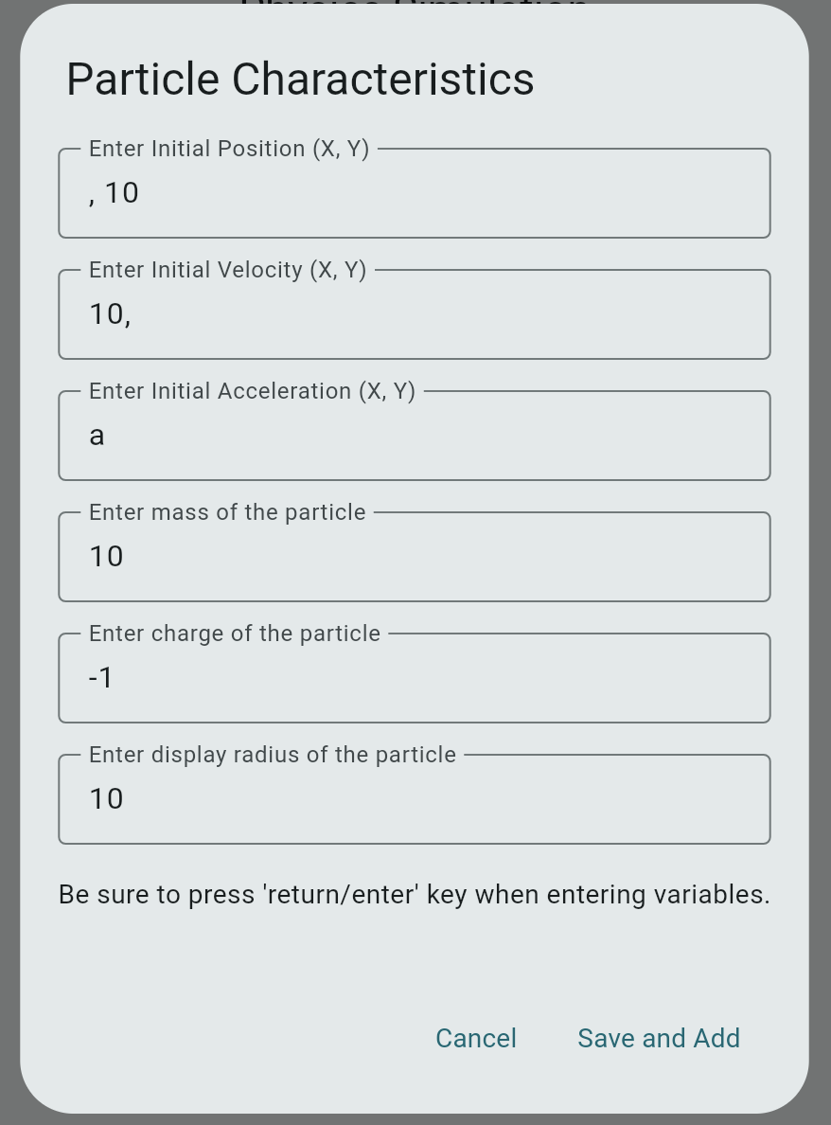
Figure 13. Illegal vector inputs
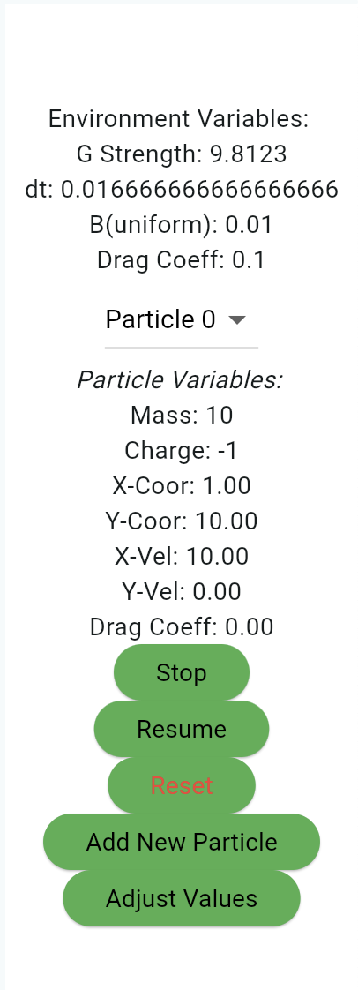
Figure 14. Adjusted Input

Figure 12 depicts a function that extracts two integer values from the textfield input and returns them as a vector.
The data type of the text field input is String, meaning any character could be entered. The input may not align with the format, or the user may not have entered both or either values. Such input errors should be treated before converting to a double to ensure robustness and prevent program failures.
Figure 13 shows illegal inputs for position, velocity, and acceleration. Position does not have any x-value input, and the velocity input has a y-value missing. Acceleration input is invalid as text is typed. However, due to algorithm shown on Figure 12, the program could filter those invalid inputs and only reflect on valid inputs, substituting wrong inputs to zero.

5. Sources

5-1. Verlet Integrator
- Verlet Integration · Arcane Algorithm Archive
- Verlet integration - Wikipedia
- Euler and Verlet Integration for Particle Physics

5-2. Boris Pusher
- Part 1 : Definition of Plasma | Importance of simulation | Boris Algorithm
- https://github.com/iwhoppock/boris-algorithm/blob/master/boris.py
- Particle Push in Magnetic Field (Boris Method)
- 4872 Why is Boris Algorithm So Good?
- Boris push with spatial stepping

5-3. Flutter’s Animation Controller&Widgets
- Flutter Animation Tutorial #6 - Animation Controllers
- Flutter FrictionSimulation Walkthrough
- Basic widgets
- Text widgets
- Flutter widget index

5-4. Accumulator Time Step Management
- Why use integration for a fixed timestep game loop? (Gaffer on Games) - Stack Overflow
- r/gamedev on Reddit: game loop comparison - which is better, a fixed step or variable delta time?
- Fixed timestep game loop, why interpolation

Word Count: 1081

